TOWN COUNCIL
DECEMBER 2010
HAPPY NEW YEAR, YA’LL !
Now that the torn wrapping paper and Christmas dinner dishes are all cleared away, we look to the New Year with hopes n dreams for 2011. But we should also look back and be happy with all we accomplished last year. This weekend we’ll throw our hats in the air and slap each other on the back in congratulations for putting on the 2010 SASS MATCH OF THE YEAR!!
That’s an honor we should all be proud of and remember for a long time to come. Its also inspiration to make the best even better this May; that’s exactly what we’ll do.
Five Dogs is our club and many hands are needed to keep it going. Offer help, but also enter up and be a part of our State Championships. It’s the same old game with a little more company so throw your hat in the ring!
And what better way to start this New Year than a weekend of shootin’ and eatin’ and just havin’ a great time with our pards? Start out on Friday with side matches galore and then the regular weekend Saturday/Sunday Match, brought to us I understand by Chama Bill and Mudhen Millie. Promises to be a hoot and a holler fit for the good cowboys and cowgirls of Five Dogs … Good Lord willin’ and the Five Dogs Creek don’t rise. Friday is predicted sunny and we’ll just have to watch for a few showers on New Years Day. Stay tuned …

Read on for more info…..

MAD DOG DRAPER (MAYOR)
maddogdraper@hotmail.com
maddogdraper@roadrunner.com
805-497-2857
MESCALERO (SHERIFF)
donkathymiller@aol.com
661-588-8978
MISS CHIEVIOUS (BANKER)
BONES BRANNON (BLACKSMITH)
richardpettit@starband.net
bones32390@hotmail.com
805-239-0738
HENNESEY HAYES (RANGE WRANGLER)
mfkelsey@hotmail.com
661-589-7510
BULL MCFEARSON (STOREKEEPER)
KentjmcKee@gmail.com
661-387-0972
DOUBLESHOT DARLIN
(NEWSPAPER EDITOR)
debi@shutttterbug.com
559-799-2829
MEMOS FROM OUR MAYOR, MAD DOG DRAPER…
Howdy All,
Hope you all had a great holiday season and will be spending New Years with us at 5 Dog Creek this year.
I would like to thank you all for a great 2010, I have many fond memories from 2010 and I can't think of anyone that isn't a part of at least one of them. Since I got involved in shooting at 5 Dogs Creek it's like I have two lives and two families, I guess i'm a pretty lucky man because I love them both. Thank you all for being there during the good times and being there to help through the bad ones which have been few. I would also like to thank the town council for everything they have done and the help and advice they have given me throughout the year, they are truly the ones that keep 5 Dogs running smoothly.
Thank you! Mad Dog Draper

Ring in the New Year with your pards at 5 Dogs Creek
Here’s a way to start 2011 off right…it's the 5 Dogs Creek New Year BLAM-O-RAMA!!!!!!!
Camping on the range will be available starting Thursday. Please no shooting on Thursday, as the range is officially closed. If you are coming out and have access to some firewood, please bring it along. Nothing says Happy New Year like a campfire with friends.
On Friday, December 31 we will have an informal day of fun side matches and plinking. Bring lots-o-ammo! Five bays will be set up. Plans include a .22 rifle “follow the leader” stage; a three person team shoot; a medium range rifle shoot at 100 and 150 yards; a man-on-man eliminator with your main match guns; and a can race with your main match pistols and shotgun….and any plinking games you can think up on your own. You can shoot these bays whenever you like and as often as you like…so remember, bring a LOT of ammo.
For Friday you'll definitely want your main match guns. You may want root around in the back of the gun safe and give some of these a workout as well:
- .22 rifles are a BLAST. Bring any old lever, pump or single shot rifle and relive your childhood. No telescopic sights, please.
- We have rifle targets at 100 and 150 yards…so here's a chance to dust off your rifle-caliber lever actions. Or your big single shot buffalo guns. Or a vintage military bolt action with lead bullet loads.
- Have an old favorite that’s been gathering dust in the back of the safe? Haven’t shot it for a while? Here’s your chance…just remember that cool guns draw an audience and your friends may ask if they can try a shot or two with Grandpa’s old “Red Ryder pump action repeater with a compass in the stock and this thing that tells time”.
REMEMBER: ALL AMMUNITION MUST BE ALL LEAD AT SASS APPROPRIATE VELOCITY!
We'll get things started about 10:00 a.m. and run until about 3:00 p.m. Cost for Friday will be $10 to pay the range fee.
At about 4:00 p.m., it's potluck time. A combo lunch/dinner…linner! Bring your “lucky” food or New Years traditions or just some great grub to share with the group. Hope everyone likes black-eyed peas!
Our regular monthly match will be January 1-2. Chama Bill and Mudhen Millie are setting up some stages they shot recently in New Mexico. Since we are known far and wide for our potlucks, we'll have a second one of the weekend starting at 4:00 p.m. on Saturday. YUM!!!!
Some other things to note:
1. If you are available on December 30 to help set-up the side matches, please contact Mescalero (donkathymiller@aol.com)
2. Help will be needed Saturday afternoon to reset Bays 1-5 for Sunday main match

WHAT I LEARNED ABOUT WILD BUNCH AT CONVENTION
by Mescalero
Over the past year, depending on who you've been talking to, Wild Bunch matches are either the saving grace of cowboy action shooting...or it's death knell. The members of the Wild Bunch committee offered several presentations at the SASS convention, and I made it my priority to attend as many as possible to better understand the implications of Wild Bunch for the state championships.

My first (and most important) learning is that there IS a long-term strategy for Wild Bunch. I had no idea. The intent is for Wild Bunch to be the THIRD shooting discipline under the SASS organization. We already have cowboy action shooting and mounted shooting as two very different venues....Wild Bunch is meant to be a third discipline.
Much of my confusion stemmed from the approach of including Wild Bunch as a side match or in association with cowboy action shooting events. The Wild Bunch committee did this intentionally during their start-up phase to generate interest and evolve their rules/procedures....but eventually they see Wild Bunch shoots as being as separate from cowboy action shooting as mounted shooting is today.
Another frustration as match director is that there was no standard rule book for Wild Bunch matches...there were only a set of guidelines. A milestone in the evolution of Wild Bunch is that there is now an OFFICIAL shooters handbook, and word is that an RO course is being developed. All future contracts for state and above SASS-sanctioned matches will require that any Wild Bunch events MUST adhere the formal Wild Bunch rule book.
There are several differences between cowboy action shooting and Wild Bunch...now that I know the intent is for two separate shooting games, I am much less concerned. Some of the key points that were emphasized by the Wild Bunch committee members were:
- Wild Bunch is NOT cowboy action shooting with a 1911. The differences are significant enough that Wild Bunch shooters should not be mixed in with cowboy action shooting matches.
- There is a much higher ammunition power factor required than in cowboy action shooting. The intent from the beginning was that Wild Bunch be a big-bore game. Scenarios are encouraged to use knockdown targets for pistol and rifle. Shooters should expect to have ammunition regularly checked to ensure it meets minimum power factor. Expect a chronograph to be a standard feature at official Wild Bunch matches.
- Safety procedures for a semi-auto pistol are very different than for a single-action revolver. As a result, Wild Bunch range procedures are drawn more from modern shooting disciplines which assume the shooters is using a semi-auto handgun.
- The shotgun procedures for Wild Bunch are significantly different: magazine tubes are loaded at the loading table, there is no "make up" if you miss a shotgun target, and the ONLY legal shotgun is a 12-gauge Winchester 1897 pump.
- Rifles must be .40 caliber or larger in keeping with the big-bore philosophy.
Finally, I learned that SASS has contracted with a northern California club for the 2011 California state WILD BUNCH championship. This makes sense if the SASS strategy is to establish Wild Bunch as a separate shooting discipline. So, while we are planning to offer a Wild Bunch side match during our annual...it will not determine the state WILD BUNCH champion.
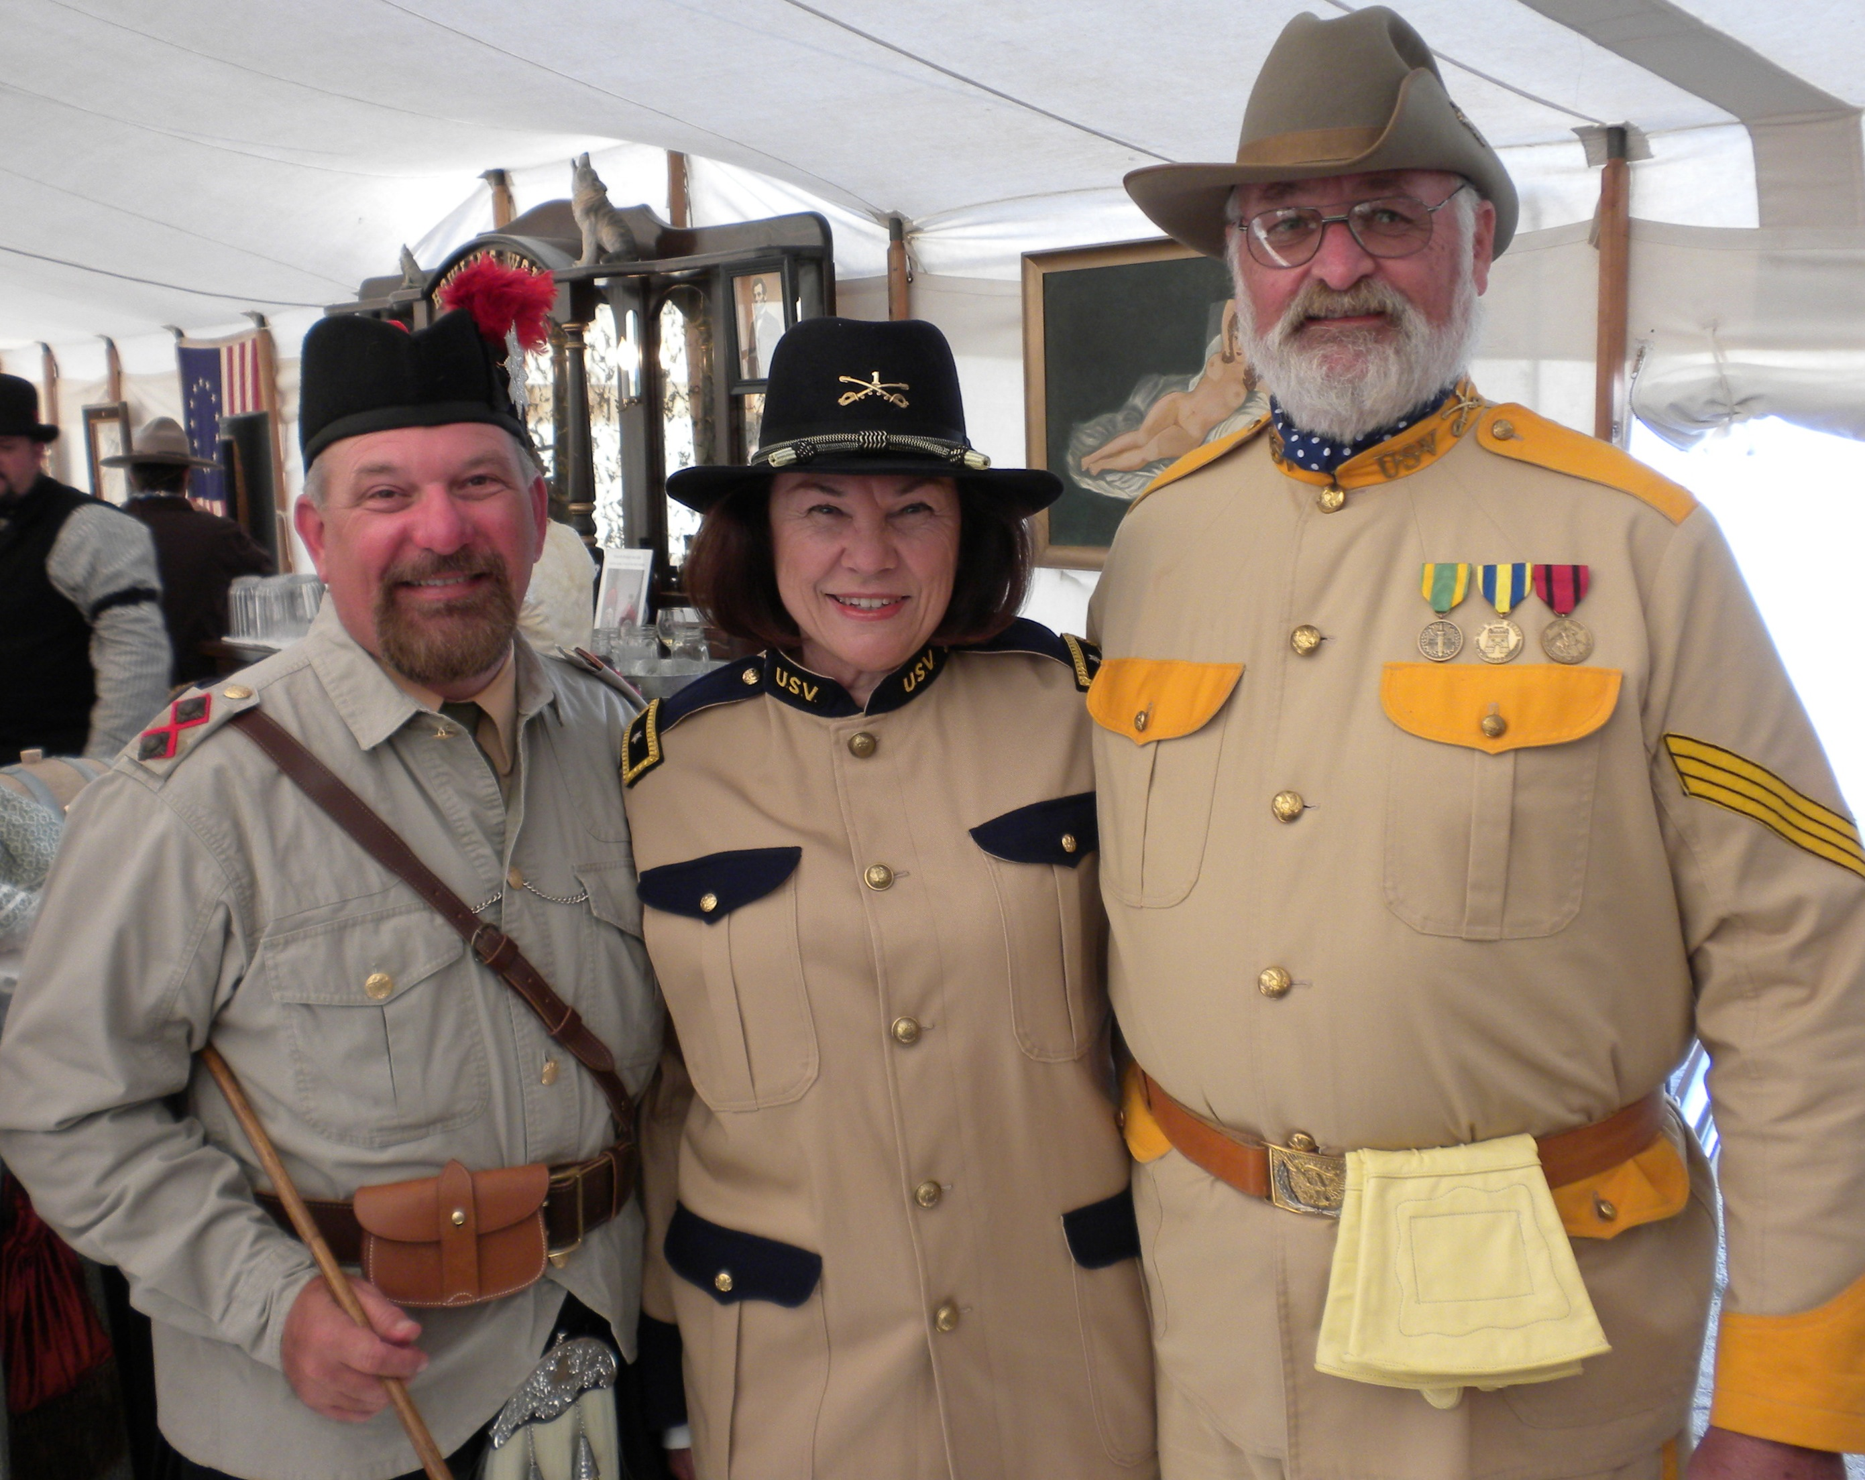

See ya all this weekend !!!!!!

